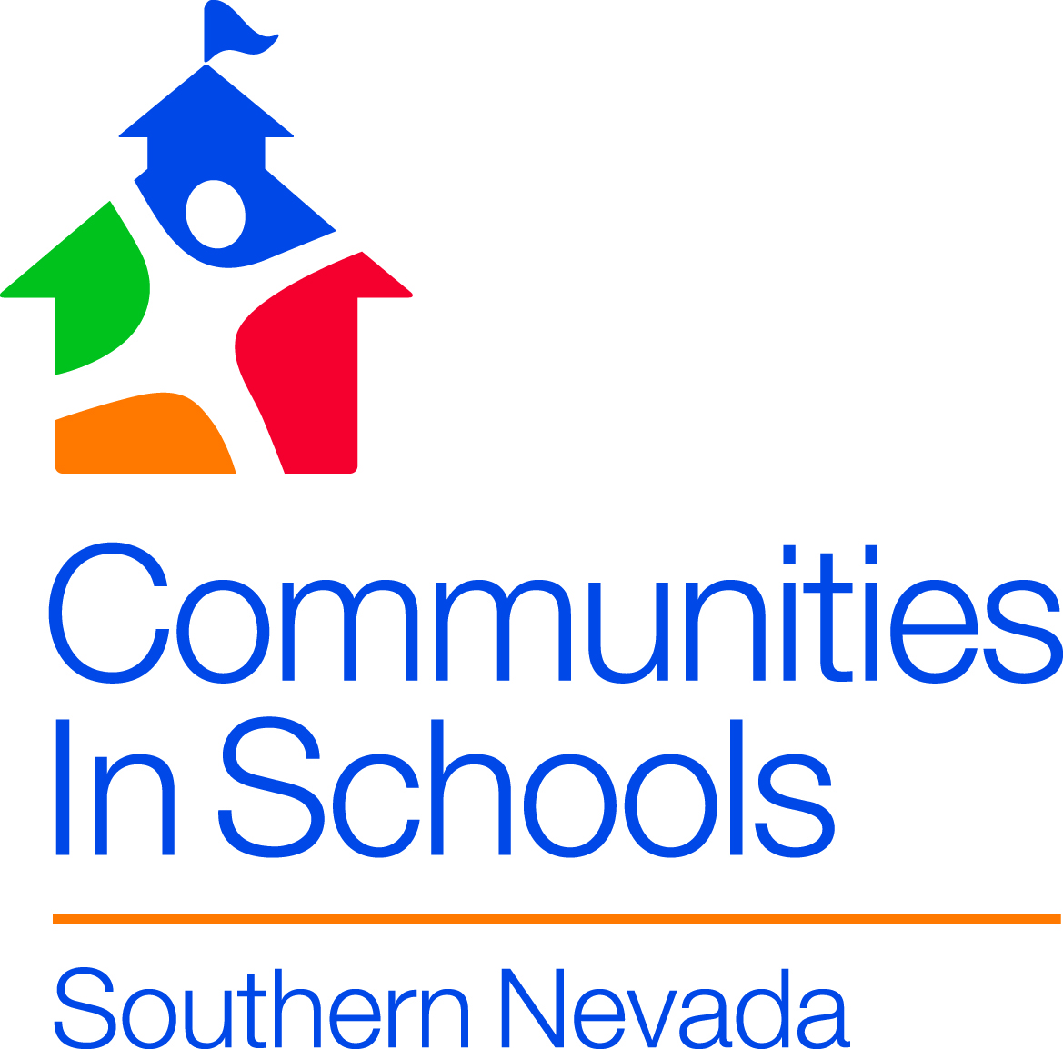
Communities In Schools
At
Diaz Elementary School

Who are we?

Communities In Schools is the nation’s leading dropout prevention organization. Our mission is simple- to surround students with a community of support, empowering them to stay in school and achieve in life.

We believe that every young person needs and deserves:

-A one on one relationship with a caring adult.
-A safe place to learn and grow.
-A healthy start and a healthy future.
-A marketable skill to use upon graduation.
-A chance to give back to peers and the community.

How we do it?

At Diaz Elementary we have a number of initiatives that are designed to assist every student. Some of our services include:

Academic Assistance Attendance Monitoring
Behavior Interventions Clothing Closet/School Supplies
Community Resource Referrals Food Pantry Referrals
Medical/Dental Referrals Case Management

Where are we?

CIS Site Coordinator: Andrea Michaels
702-799-2120 X. 4116

Andrea@cisnevada.org

MICHAA@nv.ccsd.net

The CIS Resource Room is located in room # 29

Please reach out to my e-mail address if I can assist you or your family. We are here for you!

